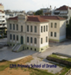
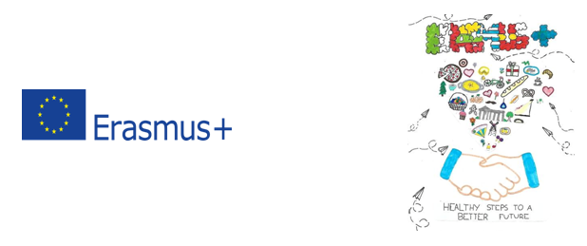

Report about the third „Healthy steps to better future” Short-term exchanges of groups of pupils in Drama – Greece
18th -21th NOVEMBER 2019, Greece
2018-1-PL01-KA229-050642
From 17 November 2019 to 21November 2019, the 3ndmeeting of the project "Healthy steps to better future" under the Erasmus + programme took place at 12th Primary School of Drama. Our guests from 4 countries - Poland, Italy, Spain, and Lithuania - were welcomed 0n 17th of November and accommodated in “Emporiko Hotel” in the centre of the city of Drama. The students accommodated in the Greek school’s students families
On the following day on 18th of November we welcomed the guests in the 12th Primary School of Drama with Greek songs and dances. After this all attending and observing the classes working with the students in their classes, talking about food traditions in Greece and the other countries. Τhe first day was followed by the following activities:
Workshop for teachers: “The cultural interconnections of Drama through international collaborations”, by Mr Savvas Dimitriadis - Manager of educational issues in Drama’s public Primary educational service - Students played traditional games
Tour of Drama (Byzantine walls, spring of Santa Barbara etc)
On 19th of November In order to learn about Greek culture and national heritage, guest teachers and pupils attended a trip to Kavala. They visited the ancient theatre of Filippi and Saint Paul’s Jail the port and the fortification of Kavala and the Panagia’s region. Everybody learned about the famous Mediterenean diet and tasted Greek food, Greek salads and fresh fruiits
On 20th of November the guests, teacher and pupils attendded the follow workshops and activities
Workshop at school “Gardening for teachers and students”
Workshops for teachers “presentation of the Greek School and educational system exchanging information about school life, school rules, staff, schedule etc”, by Mr. Ananias Tozakidis School Advisor. - Workshops for students “cooking traditional Greek biscuit
Workshop for students and teachers “learning traditional Greek dancing”
On 21th of November we all took an ecological walk and visited the “Maara Cave” and the ”Pavlidis Winery” producing the world famous Drama’s wines
Αfter our return to school Sharing follow experience and exchanging ideas about the project’s work and results during last week, evaluation of pupil’s mobility, certificates
Ιn the evening of the same day we had a formal dinner for the teachers and students at school with Greek traditional food offered by the Greek teacher and families
November 22 was the day of departure of our guests
Done by: Dr. Georgios Koutsoukis,
Project coordinator and Headmaster
23.11.2019
Drama – Greece

